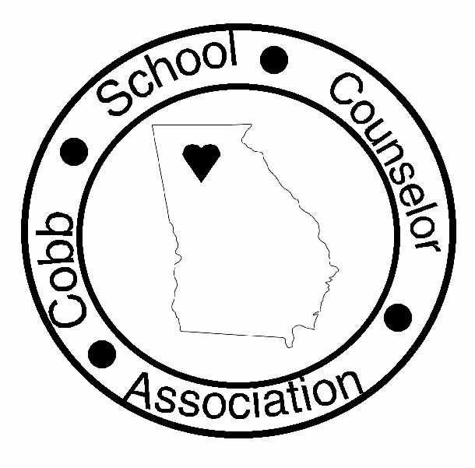
September, 2005
First Edition
Inside this Issue
President’s Letter & Welcome
2004-05 Community Outreach Program
Kudos, Feel Better, and Best Wishes
Cobb Counselor Connection
Publicity Chair Report

President Judith Morris-Reichenbach (Hightower)

Past Richard Tavernaro (N. Cobb)
President

Vice Pres Susan Strickland (S. Cobb)
(HS)

Vice Pres Lillian Douglas (Dodgen)
(MS)

Vice Pres Cathy Fogel (Murdock)
(ES)

Treasurer Callie Binzer (Chalker)
Secretary Allison Landreth (Sky View)
Publicity Charee Brown (Smitha)
Hospitality Carrie Becker (Chalker)

Advocacy Gail Smith (Oakwood)
Scholarships Jeri Bryant (Dowel)

Programs Lara Wilson (Wheeler)
Outreach A.J. Lee (McEachern)

Mini Grants Lisa King (Blackwell)

Newsletter Richard Tavernaro (N. Cobb)
Door Prizes Althea Allison Donald (Campbell)

Mentoring Colleen Brown (Tapp)

Cookbooks (TBA)

FROM THE PRESIDENT
- Judith Morris-Reichenbach

Welcome back to another school year full of excitement, challenges and changes! I am thrilled to serve as your CSCA President for this school year am excited to meet each and every one of you at our meetings. The CSCA Board met this summer and developed some exciting new ideas to add spark to our meetings.

Welcome New Counselors
Mary Ream, Nathan Schutt, Kristin Berdig, Iva Hassanzadeh, Anthony Pearson, Paula Ferguson, Karyn Corell, Sarah Haag, Rotarsha Randall Mosby, Nakia Harrison, Angelia Williamson, Eva Lee, Kellie Bartlett, Crystal Jackson, Keassa Gilliard, Stephanie David, Missy Bradley, Angela Russell, Janet Callahan, Angie Bruce, Lori Hight, Laura Miller, Kim Gray, Tanyika Butler, Charisse Cox, and Chandra Garett. New members get a free “Counselors in the Kitchen, Again” cookbook when they join CSCA. Many of our new counselors joined CSCA on Aug. 5. We hope to see the rest of you at our first get together September 13

September 13 – First General Meeting
We have decided to have our meetings on Tuesdays to allow us to adjust to the work week before making other plans. Our first meeting will be Sept. 13 at 4:00 at the Central Library on Roswell Rd and Alexander St. Many of us have already attended meetings there. We will have great food provided by CSCA, door prizes, and wonderful networking opportunities. Jeff and Patti from Prevention Intervention will share some statistics from our schools.

New Officers and Committee Chairs
It’s my pleasure to introduce you to our fabulous, hard-working officers and committee members :
Past President: Richard Tavernaro (North Cobb HS – newsletter)
V.P. High School: Susan Strickland (South Cobb H.S. – membership)
V.P. Middle School: Lillian Douglas (Dodgen M.S. – by laws)
V.P. Elementary School: Cathy Fogel (Murdock E.S. – Courtesy)
Treasurer: Callie Binzer (Chalker E.S.)
Secretary: Ann Rives (Lassiter H.S.)
Historian: Charee Brown (Smitha Middle)
Hospitality: Carrie Sutton (Chalker Elementary)
CSCA Lantern
Advocacy/GSCA Relations: Gail Smith (Oakwood H.S.)
Scholarships: Jeri Brant (Dowell Elementary)
Programs: Lara Wilson (Bells Ferry E.S.)
Outreach: A.J. Lee (McEachern, email Agnes Jones-Lee)
Mini Grants: Lisa King (Blackwell E.S.)
Door Prizes: Althea Allison Donald (Campbell M.S.)
Mentoring: Colleen Brown (Tapp Middle)
Professional Development: Brenda Pavlak (Palmer M.S.)
Cookbook Sales: Open – Anyone want to Chair this committee and help with ideas & distribution?

Recognition Award
Last years Professional Recognition Evening was a beautiful event.

Our Counselors of the Year are:
Nate Fischer – Lassiter H.S.
Judith Morris-Reichenbach – Hightower Trail M.S.
Jenni Briggs – Kemp Elementary.

Jenni and Judith went on to win Region 3 Counselor of the Year and I am honored to be Georgia Middle School Counselor of the Year and will receive my award at the GSCA conference in Augusta Nov. 18.

Mini-grants were given at the Recognition Party last May. Recipients were Cathy Fogel for Career related games, books, and software for K-5 and to Judith Morris-Reichenbach to buy books for her Ophelia Girls Leadership Groups 7th and 8th grades.

The Radiance Award went to a very worthy Tootsie Murray who lights up many of our lives.

Claire Murphy, counselor at Sope Creek Elementary, had a nice article in the AJC about the Sympathy Tea they offer to nervous kindergarten parents on the first day of school. What a sweet idea.

Executive Board Goals for 2005-2006
The CSCA Board met July 22 for an organizational meeting and to kick-start the year. Our goals for this year are to 1) increase membership, 2) involve private school and college counselors, 3) add more social and networking components to CSCA, 4) participate in a variety of Outreach Programs, 5) increase communication and 5) sell the remaining cookbooks.

COUNSELOR CONNECTION
- Dawn Haskett & Colleen Brown

All Cobb Counselors new to school counseling are invited to join a mentor program. The purpose of Counselor Connection is to provide new counselors with ideas, support, & encouragement, AND to help them to keep their batteries charged. Each new counselor will be paired with a seasoned counselor who will support him/her in many ways throughout the year. Also, all mentors and mentees will gather for three afternoon “refreshing parties” during the school year. The first meeting was Monday, August 22nd, at the Marietta Public Library,at 4:00. Contact Dawn Haskett or Colleen Brown for more information. A good time will be had by all.

PROGRAMS
- Lara Wilson
The Cobb School Counselors Association is beginning the year with a BANG! Our first program September 13 will cover networking with colleagues and powerful statistical information about your school from Prevention Intervention. The Oct. 25th programs will cover eating disorders and will meet at Los Reyes where we can hear a great speaker and get out to eat, drink, or snack. The choice is yours, but a good time should be had by all in a more social surrounding. Jan. 24, there will be a natural foods cooking demonstration for you and information on child obesity and how food affects mood. We are focused on creating programs that cover the most pressing topics in today’s schools with high interest and a social aspect. Also, we plan to increase our Outreach Program to more than one focus. Surveys will be distributed via email in the near future to determine a ‘hot topic” for Mar. 14 that you choose. Light food and drinks will be available at each meeting. We look forward to seeing you!

We listened to what you like and here is a quick rundown of future programs:

Sept. 13 (Central Library)
Networking Advantages and P/I statistics your school

Oct. 25 (Los Reyes Restaurant)
Eating Disorders (you may order food or snack on chips!)

Jan. 24 (Natural Food Mkt.)
Cooking demonstrations and Food, Mood, and Obesity

Feb. 14 (TBA)
Heart-filled culmination of Outreach Programs

Mar. 14 (TBA)
Counselors choice of topics based on future survey

COMMUNITY OUTREACH
- Joy Chanin (2005 Outreach Chair)

Our 2004-05 CSCA community outreach project was a big success. Thank you to all who participated. The Humane Society of Cobb County is a non-profit, no-kill shelter. They do not receive any tax dollars (this is NOT the Cobb County Animal Shelter). Any help they can get is
greatly appreciated. I want to share a story with you.

A lady came into the HSCC with her dog. She told them that she was out of work and was feeding her dog bread. She said she had run out of bread so could they take her dog. Instead, they gave her dog food and told her to come back for more when she ran out. She refilled her supply of dog food as needed. About six months later, she came back and said she now has a job. She can feed herself, feed her dog and thanks to the HSCC, she still has her dog.

Earlier this week, I had a crying student in my office. She was having a difficult time settling down. One of our special education classes adopted a Cockatiel and a Guinea Pig from the HSCC. I brought her to see these pets. She calmed down, returned to my office, and we talked. The animals helped her to calm down.

Animals are amazing helpers to humans. I know that our compassion to helping them has, in many ways, helped our families. Again, my thanks to all of you who participated.

KUDOS, FEEL BETTER, and BEST WISHES
- Cathy Fogel

As CSCA Vice President for Elementary counselors, I will keep you informed about the happenings reported to my by our fellow counselors. I look forward to seeing you at our first meeting in September!

Best Wishes on a personal level, are in order for the following colleagues:

Kelli Powell (Dickerson Middle) became Kelli Carlson on June 4.

Dawn Guthrie (JJ Daniel Middle) is expecting another baby in April.

Leontta Warren (JJ Daniel Middle) is expecting a baby in February.

Congratulations on a professional level to the following counselors:

Jenni Briggs (Kemp ES) is the Elementary School counselor of the year for Region 3
Judith Morris-Reichenbach is the Region 3 and Georgia Middle Counselor of the year.

Lisa King (Blackwell) did an admirable job on TV in a discussion of back-to-school preparedness, the importance of parent involvement, and the implications of high-stakes testing. She represented Cobb county counselors very well.

PUBLICITY/HISTORIAN
- Charee Brown

This is my third year as a counselor in Cobb County School District. I am an alumni of the University of Georgia where I received my certification in Early Childhood Education and Guidance and Counseling. A few of my hobbies include reading, running, and dancing. I started my tenure in Cobb County at Skyview Elementary and I have been the 6th grade counselor at Smitha Middle School for the past two years. I will serve as the Chair of Publicity/Historian for the 2005-2006 school year. My duties include maintaining the historical data accumulated by the CSCA. I will also be responsible for logging and collecting new CSCA information such as photos, pamphlets, and articles. My duties also include maintaining and updating the CSCA scrapbooks. I am excited about the upcoming year!

Each month’s Lantern, along with updated information on Cobb School Counselor Association activities and issues can be found on the Check out the CSCA Website at http://cobbcounselors.tripod.com

Purchase Cobb School Counselor Association Goodies at the CSCA Online Store, located at:
www.cafepress.com/csca
Here are a few of the things you can find there:

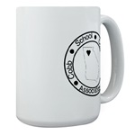
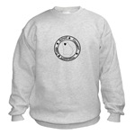


And many more – all profits from the CSCA store go to the CSCA Scholarship Fund

