CSCA Lantern
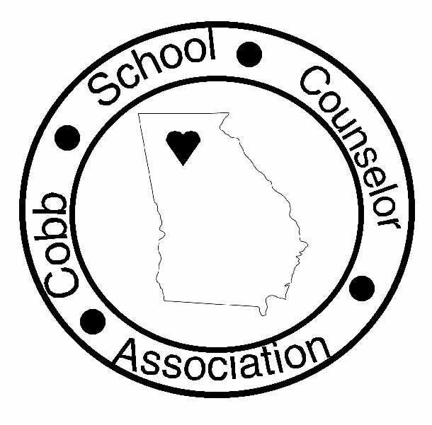

A publication of the Cobb School Counselors Association
March, 2006
Fourth Edition
Inside this Issue
President’s Letter
Programs
Kudos, Feel Better, and Best Wishes
Treasurer’s Report
Announcements

President Judith Morris-Reichenbach (Hightower)

Past Richard Tavernaro (N. Cobb)
President

Vice Pres Susan Strickland (S. Cobb)
(HS)

Vice Pres Lillian Douglas (Dodgen)
(MS)

Vice Pres Cathy Fogel (Murdock)
(ES)

Treasurer Callie Binzer (Chalker)
Secretary Ann Rives (Lassiter)

Publicity Charee Brown (Smitha)
Hospitality Carrie Sutton (Chalker)

Advocacy Gail Smith
Scholarships Jeri Bryant (Dowell)

Programs Lara Wilson (Wheeler)
Outreach A.J. Lee (McEachern)

Newsletter Richard Tavernaro (N. Cobb)
Mentoring Colleen Brown (Tapp)

Cookbooks Lara Wilson (Wheeler)

Mini Grants Lisa King (Blackwell)

http://cobbcounselors.tripod.com

FROM THE PRESIDENT
- Judith Morris-Reichenbach

It is hard to believe that this is the last edition of the Lantern for the 2005-2006 school year! I want to thank Richard Tavernaro, our Lantern editor, for all the time and effort he puts into the Lantern. Richard you do a great job, thanks.

I also owe a big thanks to the CSCA board for their dedication to and hard work for CSCA this year. You made my job so much easier and a lot of fun!! The officers and Chairs were unbelievably devoted and hard-working. A special thanks to Lara Wilson who took on any task that needed to be done including door prizes, cookbooks sales, decorations and programs. She was my rock. V-P of Elementary School, Cathy Fogel’s experience was invaluable as I was so new at what I was doing. She kept me on the right track. Thanks to Treasurer, Callie Binzer for her accurate accounting and working with the cookbook donations and sales. V-P of High School, Susan Strickland’s input was greatly valued, and she EXCELed our memberships as they kept rolling in all year long. Thanks to our Outreach Chair, A.J. Lee who put her heart into the programs and negotiated with Georgia Pacific for those boxes we all got. She was even trying to get permission to drive a U-Haul around to the schools to pick up the donations for us. Nice try A.J. Thanks to Secretary, Ann Rives for writing our minutes even through all the heavy discussions. Hospitality Chair, Callie Sutton saw that we had some wonderful food at our meeting to satisfy everyone’s palates. Among the other hard-working crew are V-P Middle School, Lillian Douglas; Historian, Charee Brown; Scholarship Chair, Jeri Bryant; Mini Grants, Lisa King; Mentoring, Colleen Brown; and Professional Development, Brenda Pavlak my devoted helper who also introduced me so eloquently at GSCA Awards Banquet. And, of course, our own Gail Smith our Advocacy Chair who works so hard for us here in Cobb and through GSCA. It’s a pleasure to now have her as our supervisor. We know she will work hard to ‘chip away at the wall’ for us. Thank you everyone. It was a pleasure to be associated with such great professionals.


Thank you also to those of you who joined CSCA and helped us with the sale of our Counselors in the Kitchen Again cookbooks. Half of the money went to the American Red Cross to help with disaster relief, a very worthy cause. A big thanks to all of you for the wonderful response to the Counselors Have a Heart For Giving Campaign that culminated at Valentine’s Day. Warm clothing was collected by our counselors across the county as well as a plethora of activities to make life a little easier for many needy people. Awards will be given at the March 14 meeting to the groups of counselors with the most hours and commitment to children. Because of your efforts, we are able to donate money to the Red Cross and present the following awards on our Professional Day, May 18:

$1,000 in Scholarships

$600 for 3 Mini Grants

The Radiance Award Trophy

Janet Hosler, our President-Elect, will present our new slate of Officers and Chairs at the next meeting which will take place March 14 at the Marietta Central Library with socializing starting at 4:15. The program for this meeting will include Counselors Have A Heart For Giving Campaign Awards, A Smoking Cessation (Quit Line) speaker, and round-table discussions of pertinent topics for counselors at all levels led by an experienced counselor.

Attached to the Lantern is a form for nominating a counselor for the coveted Radiance Award. This is an award presented by CSCA at the County Professional Day, May 18. Please read the criteria and nominate a much-deserving counselor for this award. Please note that this is due back to Candace Pearce at Dickerson Middle School by March 20. Also, don’t forget to nominate your favorite candidate for Counselor of the Year.
Lastly, I would like to thank all of you for allowing me the privilege of serving as President of the Cobb School Counselor Association. It has been a wonderful growing experience for me, and a privilege to serve on such a supportive professional organization. I look forward to many more years of involvement.

Don’t forget the Cobb Professional Day with CSCA Recognition May 18 at Southern Polytechnic Institute at 8:00 in the ballroom with breakfast provided by Dr. Coker of SPSU.

Best wishes to all of you for a successful end of the school year.

PROGRAMS
- Lara Wilson

A Banner Year for CSCA Programs

The 2005-2006 school year programs included the following presentations:

- Prevention and Intervention helped kick-off our school year with a presentation on how to work with students and families in the wake of Hurricane Katrina
- Peachford and Ridgeview counselors dined with counselors at Los Reyes and presented a refresher course on eating disorders, the latest statistics, and what each program offers
- David Gephardt gave counselors some healthy advice on how to eat better and educate our students and parents about the toxins we currently consume on a daily basis
- UPCOMING MEETING: COUNSELORS’ CHOICES. A round table discussion with 3-5 experienced counselors at all three educational levels will take place on March 14 from 4:15 – 6:15 PM at the Marietta Central Library. Bring those burning questions of yours to the table for some excellent advice.

We hope that you found value in our programs this year. If you would like to volunteer as the Programs Director for CSCA during the 2006-2007 school year please contact Janet Hosler as soon as possible. Developing programs for each meeting is a valuable and easily manageable task. Please contact Lara Wilson if you have questions about the duties of the position.

Calling ALL Cooks!

Anyone interested in volunteering to manage the CSCA cookbook sales for 2006-2007 should contact Lara Wilson as soon as possible.

TREASURERS REPORT
- Callie Binzer

I have really enjoyed serving as CSCA Treasurer for the 2005-2006 school year! It has been a quick and busy year! Looking back on this year, I am reminded of the many ways we helped the Katrina families at our local school and through our organization’s awesome outreach projects! Counselors do have a heart for giving! Thank you for responding to that wholeheartedly this year! I hope everyone has a peaceful rest of the year and wonderful summer vacation! Below is a summary of the current funds in CSCA’s budget as of March 7, 2006.

Balance brought forward as of October 25, 2005 $4215.06
Deposits (New Memberships & Cookbook Sales) $320.00

Disbursements (food, speaker gifts & Donations to American Red Cross) $122.61

Ending Balance as of March 6, 2006 $4412.45

KUDOS, FEEL BETTER, and
BEST WISHES
- Cathy Fogel

I have enjoyed sharing news with you this year about personal and professional events in your life. It’s always important to remember to take care of yourself and to celebrate the successes in our life despite our hectic work schedule. Here is the latest information about your colleagues. We need to be proud of all of these wonderful accomplishments and special happenings in our personal lives.
Congratulations to:
Lisa King (Blackwell ES) has a newly published second book entitled
Academic Advisement Program for Grades 4-6: Lessons, Activities, Games and Reproducible Forms & Handouts to Help Students Become More Successful in School. It is very user-friendly and is a great way of implementing intentional guidance. It is published by Youth Light and can be found on their website.

Erin Mason (East Cobb MS intern) has been named “Outstanding Doctoral Student” in the Counseling and Psychological Services Dept. at Georgia State University.

Richard Tavernaro (North Cobb HS) who was named Cobb County Coach of the Year by the Cobb Swim Coaches Association.

New family members:
Jennifer Scott (Smitha MS) gave birth to Samuel Ambrose on October 18th.
Connie Plunkett-Thompson had a little boy, Atticus on November 16th.

Expecting babies:
Lara Wilson (Bells Ferry ES) is expecting a baby boy on June 7th.

Callie Binzer (Chalker ES) is expecting her first baby on July 9th.

Kristin Hartzheim (Nickajack ES) is expecting her 2nd baby due on Sept. 7th.

Sheila Veatch (Ford ES) is proud to announce that she will soon be called Grandma when a new precious little girl arrives in May.

Wedding Bells are ringing for:
Ayiesha Huguinea (Austell Intermediate) will be wed May 6!
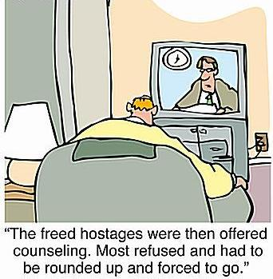

Successful Fundraisers ~ Pennies for Patients
Loretta Davis & Diedra Milligan (Brumby Primary and Intermediate ES) raised $2466.55. Intern Kate Strother (Georgia State) was the Penny Princess and visited all the classes to explain to the children the importance of donating money for research.

Brinne Pruett (Murdock ES) led the Student Council in successfully raising $2469, which surpassed previous collections.

Special Recognition:
Julia Richardson (Campbell HS) received a letter from First Lady Laura Bush recognizing her service to students as a “positive role model and an excellent leader.”

Outreach Activities
Gail Wylie (Durham MS) has volunteered for Divorce Care for Kids at her church for the last eight years. She teaches a weekly seminar for adults to provide help and healing for families of divorce.

ANOUNCEMENTS

~A.J. Lee - Community Outreach Coordinator
Thanks to all of you who got the word out and encouraged participation in our community service project, collecting warm clothing and toiletries for Must Ministries. You have truly confirmed our campaign theme that Counselors Have a Heart for Giving! Special thanks also go out to Janet Brannen and Johnny Johnston for coordinating the receipt and delivery of over 500 boxes for the campaign, from our friends at Georgia-Pacific. You have all done an outstanding job and have blessed our neighbors in need. Words cannot express my appreciation, and again, I extend my gratitude to you for a job well done.

~ Janet Hosler - President-Elect
I have been working on placement of officers to serve on the Executive Board for the 2006-07 school year. In addition to Executive Board members, a slate of chairpersons for our committees is needed. Positions still needed on the Board are VP for elementary and Historian. Positions needed for committee chairpersons are Hospitality, Programs, Outreach, Mini-Grants, and Door Prizes. Since CSCA includes counselors in the Marietta City School District, we want representation from Marietta.

If you are interested in serving in a leadership or supportive role with CSCA, please get in contact with Janet at Oakwood High School by calling (678) 594-8240 X224 or by email:
janet.hosler@cobbk12.org

$$$$ MINI GRANTS $$$$
~ Lisa King - Mini-Grant Chairperson

The CSCA board has recently approved three mini-grants to be awarded at our May meeting!!! CSCA offers you an opportunity to apply for these mini-grants, which are funds specifically to be used by School Counselors to purchase counseling materials or programs. The amount of grants will vary, with a maximum award of $200. The amount of any grant will be determined by the following criteria: the quality of the submitted application, relevance of request to the needs of a student population, completeness of the application. Applications have been sent to you, so think about what materials you might be able to purchase so that your programming can contribute to student success.
In addition to the mini-grants offered to support counseling projects, a mini-grant will be available to cover the conference fee/registration dues for this summer’s American School Counselor Association Conference. (If approved, the individual will be required to pay for travel and lodging expenses for the conference.) The winner of this grant will also be asked to present information learned at the ASCA conference at a future CSCA meeting. If you are interested in going to the ASCA conference from June 24 - 27, 2006 in Chicago, Illinois, this is a great opportunity.

If you have any questions, please email Lisa King or call her at 678-494-7603 x231.

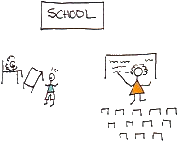
Last Call For Scholarship Applications!!

The Cobb School Counselor Association offers 2 scholarships each year, a service scholarship and one for a son or daughter of a CSCA member. Applications are due to Jeri Bryant, Scholarship Chairperson, by March 31. A scholarship screening committee will review all applicants and decide on the recipients. Applications should be available in your high school guidance office. Please contact Jeri Bryant at 678-594-8062 with questions.

Professional Development
~ Brenda Pavlak

Cobb County counselors are committed to continuing education, continuing professional growth and skill development. We are very fortunate to have many opportunities throughout the school year for conferences and seminars in our state and in the Atlanta area. Through Georgia School Counselors Association, CSCA, Kennesaw State University, Georgia State, West Georgia, Ridgeview Institute and other hospitals, staff development through the school district, and a myriad of private mental health practitioners, we can take advantage of numerous opportunities for learning and growth.

Georgia Tobacco Quit Line
~ Sandra Stuart - Guest Speaker at March CSCA Meeting

As a school counselor you work with students to get them to quit smoking and now there is good news: fewer Georgians are smokers compared to two years ago. This was confirmed in a recent report by the U.S. Centers for Disease Control and Prevention (CDC) that also lists smoking in the state below the national average. Health officials point to tobacco reduction efforts that include the Georgia Tobacco Quit Line, ongoing education, and a new state law that prohibits smoking in public places.

Unfortunately, every day nearly 4,400 young Georgians between the ages of 12 and l7 start smoking and about half of these youth will become daily cigarette smokers. The CDC has found that almost 23% of high school students smoke and the gender breakdown is 24.6% males and 21.2% females. Sadly, over 10 % of our middle school students are smoking and the gender breakdown is almost even.

Launched in 2001, the Quit Line (1-877-270-STOP; Spanish: 1-877-2NO-FUME; TTY: 1-877-777-6534 for the hearing impaired) is a free resource for Georgia tobacco users ages 13 and older. The Quit Line provides counseling, a resource library, support and referral services. Callers speak with healthcare professionals who develop a unique plan for each individual. To date, nearly 45,000 Georgians have called the Quit Line for help. Smokers have reported marked success in their efforts to go smoke-free thanks to the Quit Line. Youth cessation services offered by the Quit Line are an added benefit to school counselors who encounter teenagers using tobacco products.

Quit Line educational materials are available to display in your school or to give to your students. Quit Line posters, brochures, and flyers also are available in English and Spanish to assist you in raising awareness about the Quit Line. For additional information about the Georgia Tobacco Quit Line or to request promotional materials, please call 404-367-2762.

Being smoke-free is part of the Live Healthy Georgia campaign launched by the Georgia Department of Human Resources (DHR) in partnership with Gov. Sonny Perdue. The statewide outreach initiative encourages Georgians to follow five steps for better health and well-being: Eat Healthy, Be Active, Be Smoke Free, Get Checked and Be Positive. To learn more about the Live Healthy Georgia campaign, visit:
www.livehealthygeorgia.org.

Pictures from the Past Month

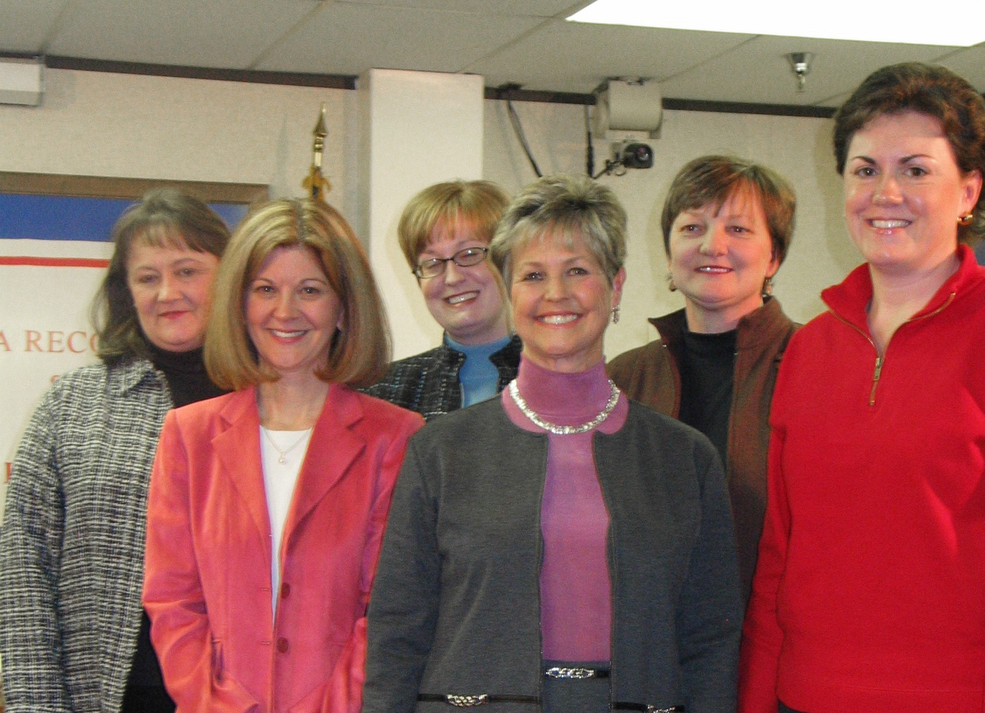
Cobb School Board giving counselors Proclamation for National School Counseling Week

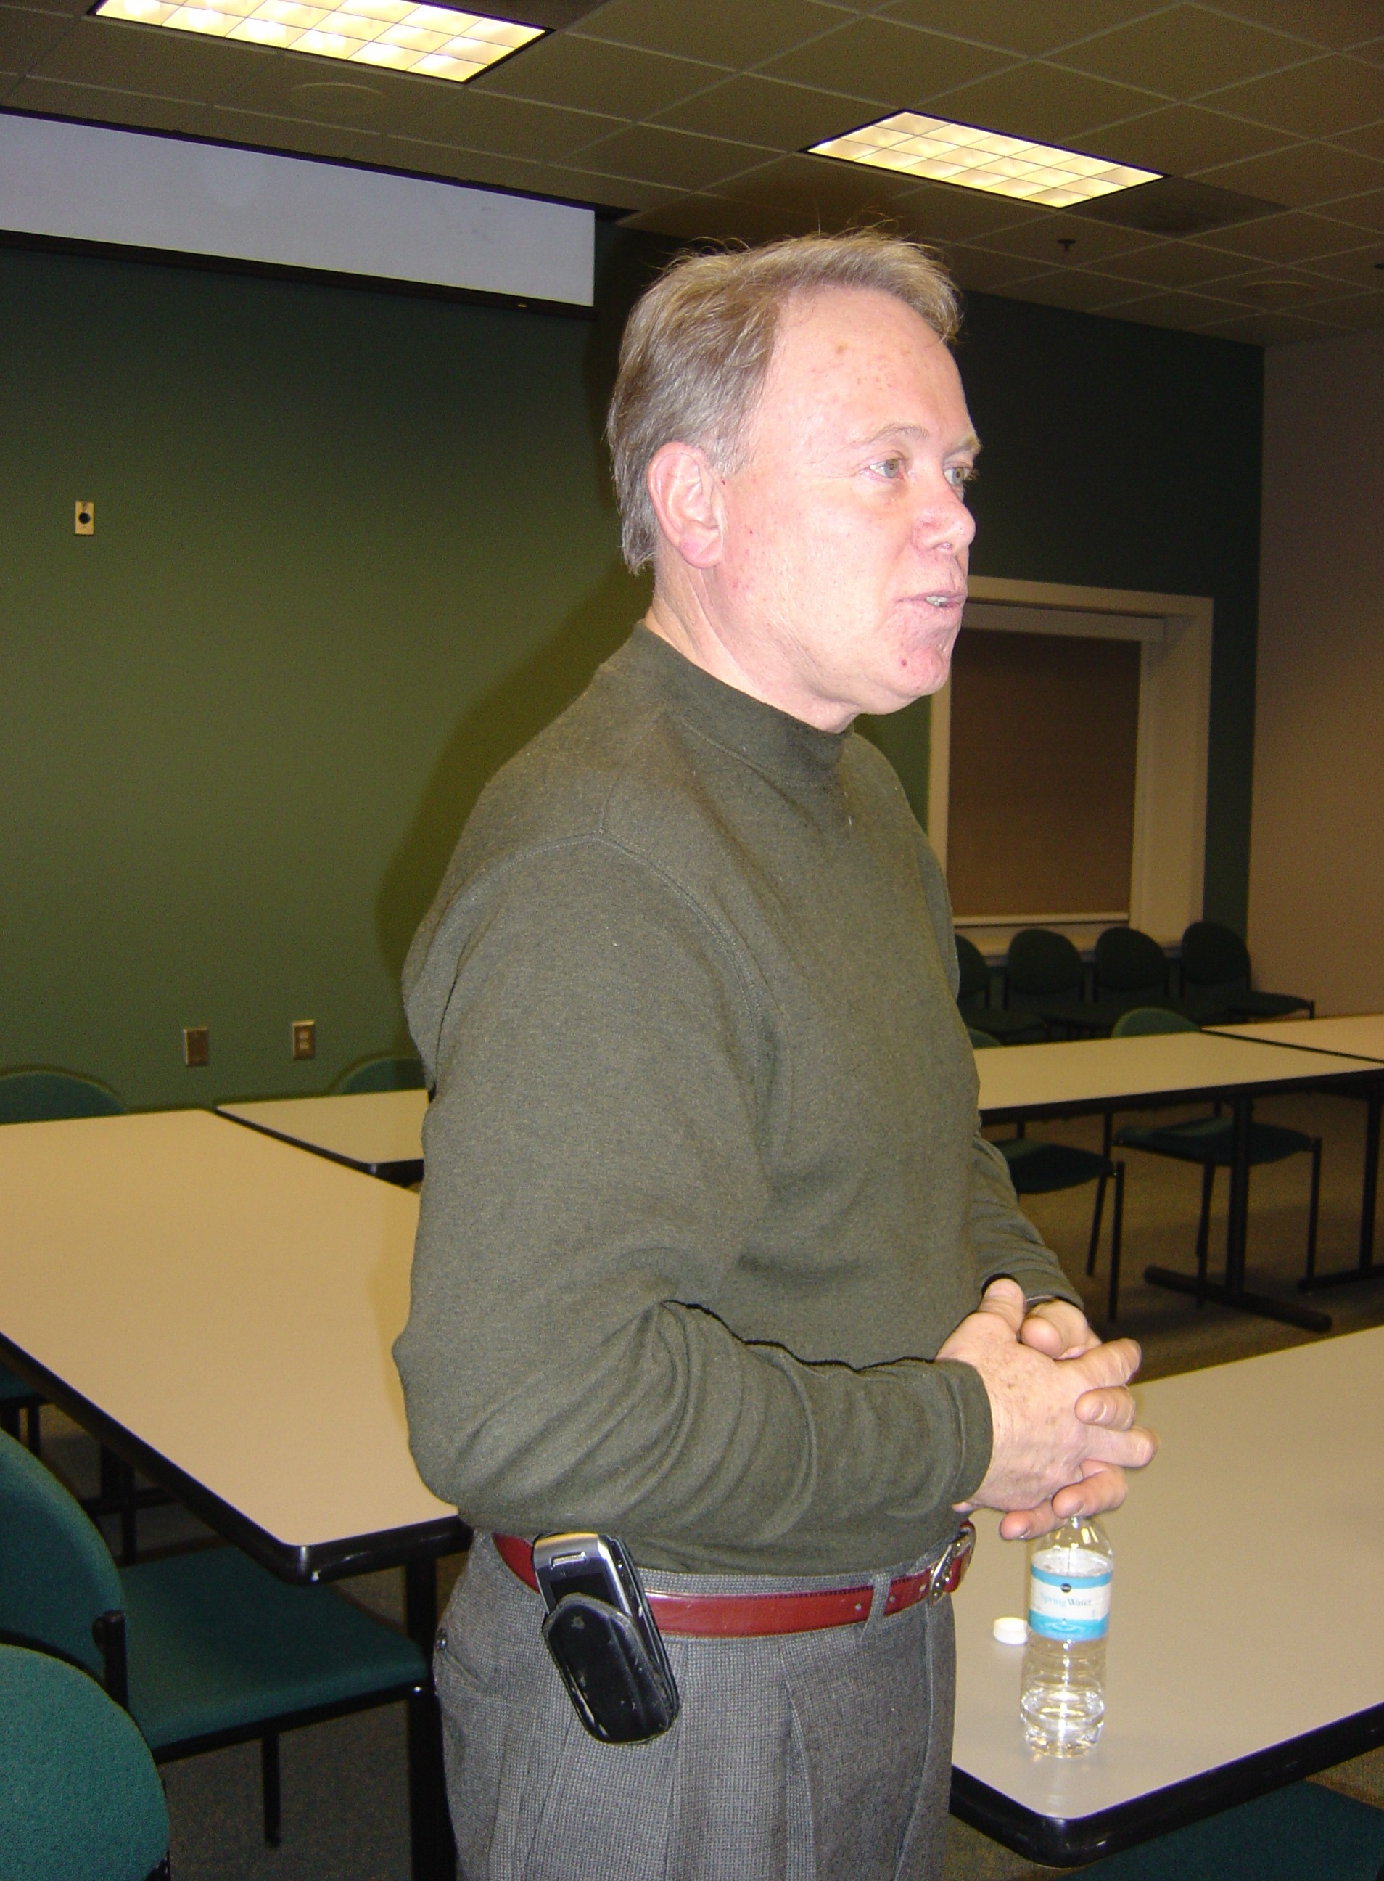
David Gephardt, owner Natural Foods Market speaking on Obesity in Children

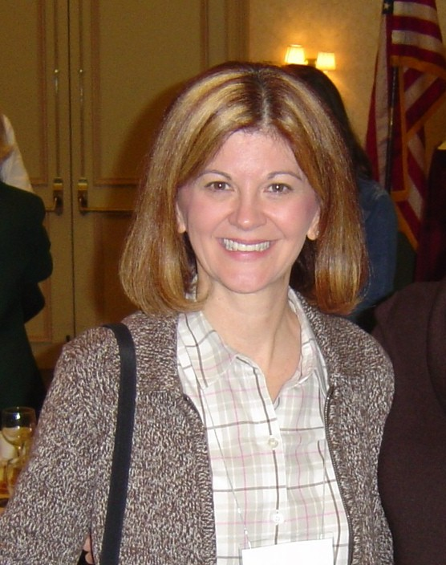

Gail Smith introduced herself at CSCA

Each month’s Lantern, along with updated information on Cobb School Counselor Association activities and issues can be found on the Check out the CSCA Website at http://cobbcounselors.tripod.com

Purchase Cobb School Counselor Association Goodies at the CSCA Online Store, located at:
www.cafepress.com/csca
Here are a few of the things you can find there:
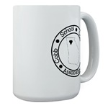


AND MANY MORE – All proceeds from CSCA Store sales go into the CSCA scholarship fund

We received the following letter from the Red Cross thanking us for our donation to the Katrina Relief Fund:
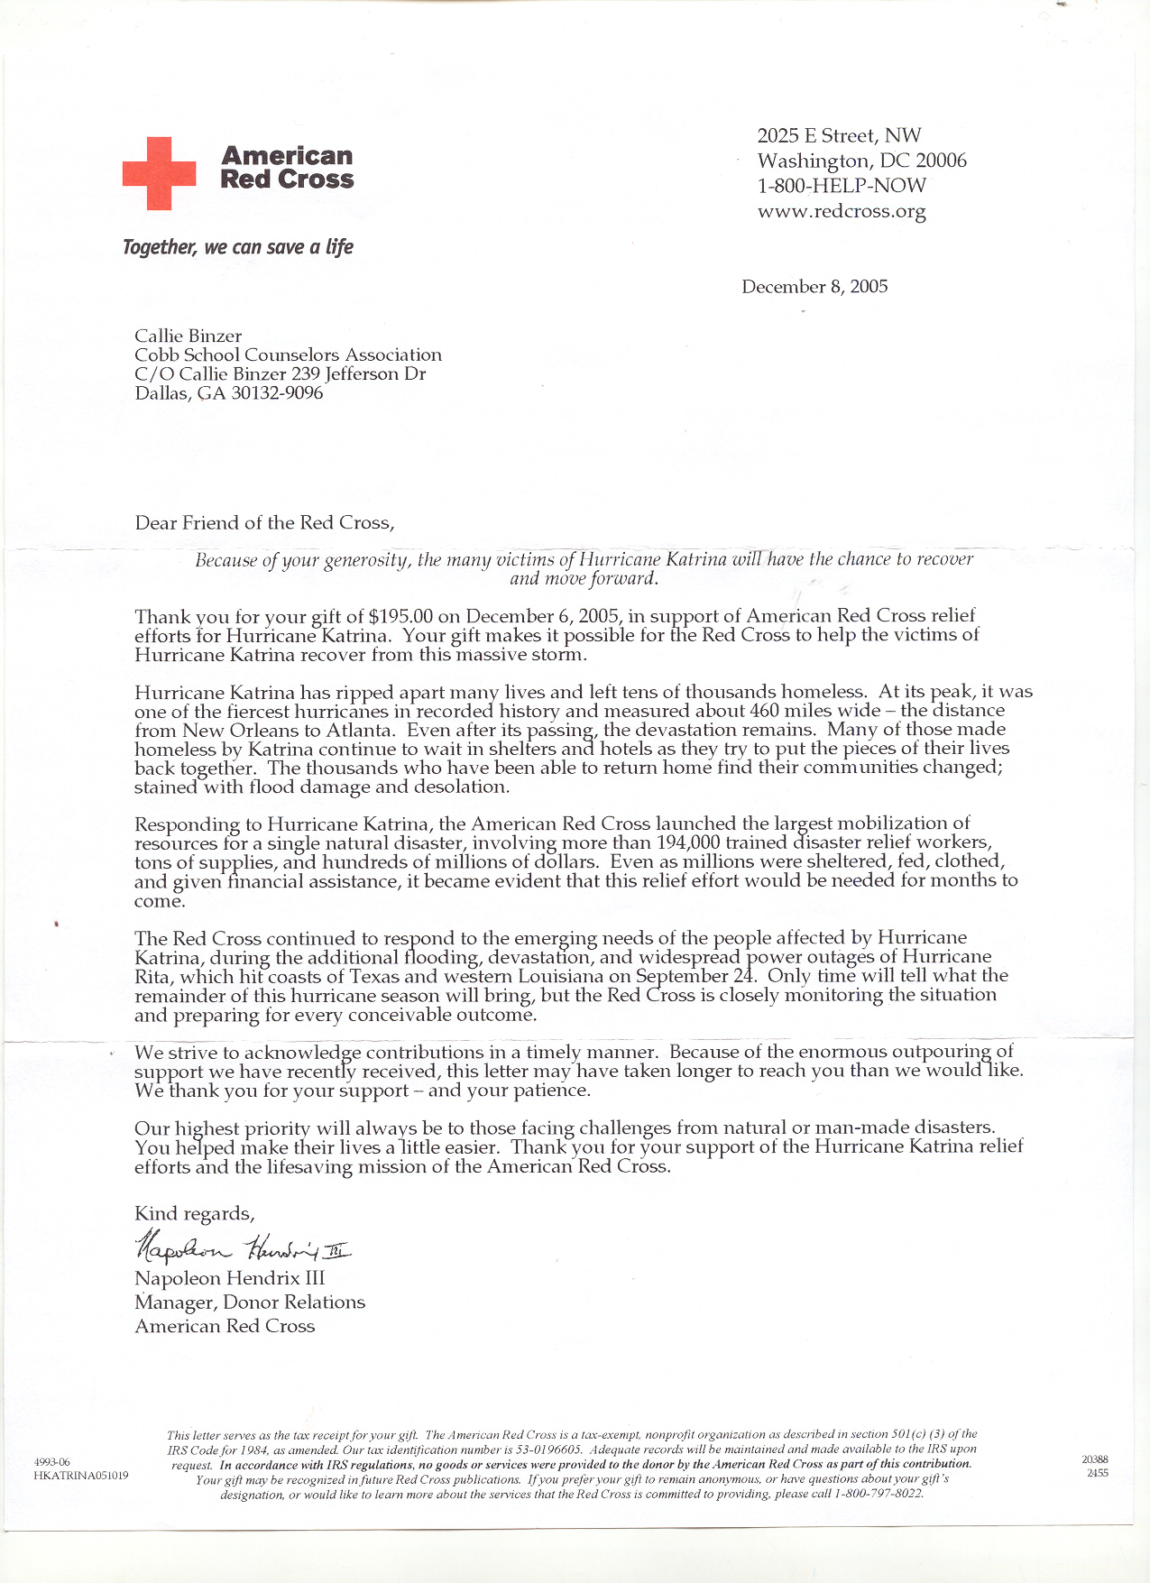
- RADIANCE AWARD -
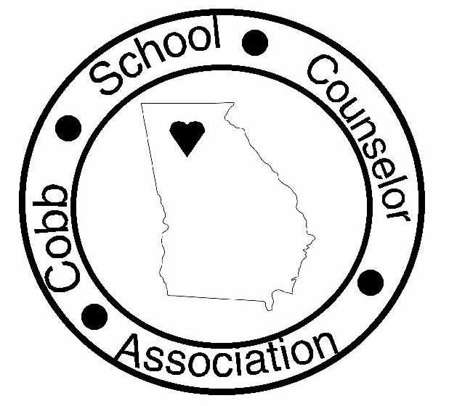
Given by the Cobb School Counselors Association

This is an award given to a Cobb or Marietta City counselor who shows exceptionality in the field of counseling and involvement in the Cobb School Counselors Association.

The criteria for the award is:
- Be a member in good standing of CSCA for 3 years
- Be actively involved in CSCA and made significant contributions to the organization
- Be a practicing counselor for at least 7 years
- Demonstrate enthusiasm for the profession
- Be an inspiration to the other counselors and staff
- Has never won the radiance award before

Please nominate a counselor who you feel deserves this award:

I wish to nominate ___________________________________ who works at _______________________________________.

The reason I am nominating this person is: (use back of sheet if needed) Please do not attach additional pages.

*Please send completed nomination form to Candace Pearce at Dickerson Middle School or email at Candace.Pearce@cobbk12.org by March 20, 2006.
COBB SCHOOL COUNSELOR ASSOCIATION

Membership Application
Office use only
Susan __________
Judith __________
Callie ck. # ____________

Date___/___/___

Please complete all of the following:

___________________________________________________________________________________________________
Last Name First Name Middle Initial

Home Address: ______________________________________________________________________________________

___________________________________________________________________________________________________

Phones-Home: _________________ School: ______________________ Cell: _______________

Preferred email: ______________________________________________________________________________________

School Name: _______________________________________________________________________________________

School Address: ______________________________________________________________________________________

Certifications: _____ NCSC _____ NCC _____ LPC _____Other________________________________

I am a member of: (Check all that apply)

_____ CSCA _____ GSCA _____ ASCA _____ ACA _____ GAE _____ PAGE

Membership Options:

_____New Member (or) _____Renewal

_____School Counselor ($15) _____Retired ($5) _____Intern/Practicum ($5)

_____Affiliate ($15) _____ Past President (no charge)

I would like to help on the following committee(s):

_____ Hospitality _____ Scholarship _____ Mentoring _____Community Outreach

_____ Advocacy _____ Door Prizes _____ Programs _____ Professional Development

_____ Cookbook Sales _____ Membership _____ Officer or Committee Chair next year

_____ Professional Recognition Banquet (this is a very important program)

The membership fee for a year is $15.00. Please make your check payable to Cobb School Counselor Association and mail along with this application to: Susan Strickland at South Cobb High School

